Mixed Blessings Programme – Summer 2024

Date | Talk/ Activity | Speaker/ Organizer | Meal
16th Apr | Lifting the Lid | Miranda Pender
23rd Apr | A Career in the Military | Neil Murdock | Cooked Meal
30th Apr | Wobble (Seated exercise) | Gill Tennant
7th May | Tales of a Roving Reporter | Alan Jones | Fish and Chips
14th May | Craft | Jenny Singleton
21st May | Music | John Harpham | Cooked Meal
28th May | Put Your Best Face Forward | Jane Glennie
4th June | Origins of Pub Names | Anthony Poulton Smith | Fish and Chips
11th June | Visit to Branksome Dene | --- | Bring your own lunch.  Pudding will be provided
18th June | Call My Bluff bygone quiz | Morgan, Ivan and Eric | Cooked Meal
25th June | So Far So Good | Malcolm Wells | Planning Meeting
2nd July | Wobble (Seated exercise) | Gill Tennant | Fish and Chips
9th July | Coach Trip to Redlands Yard and West Bay
16th July | Visit from Merley First School | Year 4 Children
23rd July | Musical favourites | Nick Sellers | Cooked Meal
30th July | Coffee and Chat | -
6th Aug | Coffee and Chat | -
13th Aug | No Mixed Blessings | Childrens Holiday Club

Coffee and Chat sessions continue until the Autumn term which begins on 3rd September.
Please turn over
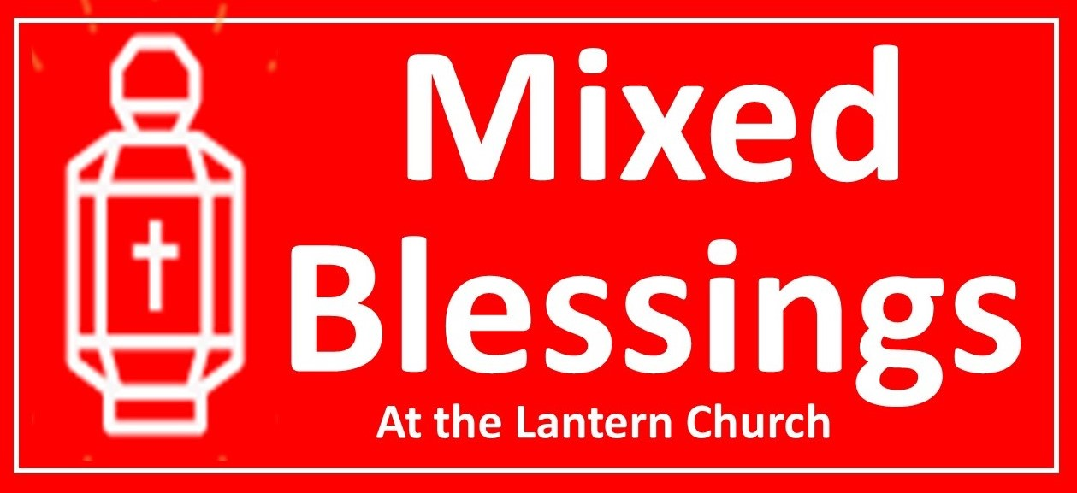

Hello!
Welcome to a new term of Mixed Blessings. You will see from the programme overleaf that we have a full and varied selection of activities this term. There are return visits from old friends and speakers fresh to us.

We have booked the community room at Branksome Dene for 11th June so that we can have our annual visit to the seaside. No guarantees, but the weather is usually very kind to us for this and we spend time sunbathing, playing games, strolling along the prom, and chatting.
On 9th July we plan to have a coach trip through the wonderful Dorset countryside to Redlands Yard in Broadwindsor, and the harbour at West Bay. Redlands Yard is a craft centre with a handful of retail outlets and a very pleasant restaurant where you can enjoy a coffee if you want. West Bay has a very picturesque harbour and a plethora of fish and chip emporia and cafes where you can take pleasure in lunch. You can even go crabbing if it takes your fancy!

We end the term with a visit from Nick Sellers. Last time he came, people said that his voice was good enough to sing on the London stage, and between songs he keeps us entertained with his witty repartee.

If your new to mixed Blessings, here is the normal pattern of the meetings:
10:30 Arrive, drink hot drinks, chat and eat biscuits.
11:00ish Notices, Birthdays, Bible talk, Prayers, Talk or Activity
12:00 End or (fortnightly) Meal

With kind regards,
Derek.

